SEO Analyser Manual Guide

## Table of Contents

A1: Introduction 3

B1: Environment 3

B2: How to run Application? 3

C1: How to perform URL SEO Analysis Test? 3

C2: How to perform String SEO Analysis Test? 6

# A1: Introduction

This document explains, what technologies used for develop the SEO Analysis system and user guide to use the system.

# B1: Environment

* **Technology**
* Visual Studio 2010
* C#, Asp .Net and .Net Frame work 4.0
* **Operating System**
* Windows

# B2: How to run Application?

# 

* Local Host (Open application in Visual studio 2010 are greater version and Run)
* IIS Hosting

# C1: How to perform URL SEO Analysis Test?

* Enter URL in the text box.
* Select ‘IsURL’ check box.
* Select the Analysis option listed in the check box and Search
* Result will be listed in the table format with Paging and sorting option.

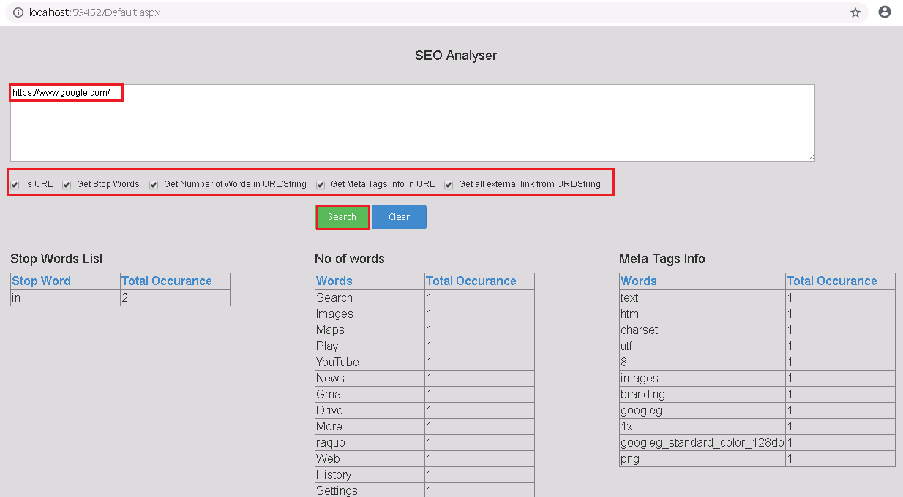

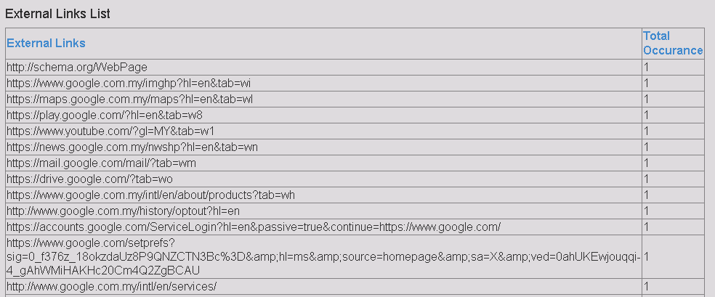

# C2: How to perform String SEO Analysis Test?

* Enter Search Text in the text box.
* Un Select ‘IsURL’ check box.
* Select the Analysis option listed in the check box and Search
* Result will be listed in the table format with Paging and sorting option.

